**“E-KETHA” : ENRICHING RICE FARMER’S QUALITY OF LIFE THROUGH A MOBILE APPLICCATION.**

2022-81

Project Proposal Report

Salika Madhushanka W.J

B.Sc. (Hons) Degree in Information Technology

Department of Computer Science and

Software Engineering

Sri Lanka Institute of Information Technology

Sri Lanka

February 2022

**“E-KETHA” : ENRICHING RICE FARMER’S QUALITY OF LIFE THROUGH A MOBILE APPLICCATION.**

2022-81

Project Proposal Report

Salika Madhushanka W.J – IT19101620

Supervisor: Mr. Adeepa Gunarathna

Co Supervisor: Ms. Amali Upeka Gunasinghe

B.Sc. (Hons) Degree in Information Technology

Department of Computer Science and

Software Engineering

Sri Lanka Institute of Information Technology

Sri Lanka

February 2022

# **DECLARATION, COPYRIGHT STATEMENT AND THE STATEMENT OF THE SUPERVISOR**

We declare that this is our own work and this proposal does not incorporate without acknowledgement any material previously submitted for a degree or diploma in any other university or Institute of higher learning and to the best of our knowledge and belief it does not contain any material previously published or written by another person except where the acknowledgement is made in the text.

|  |  |  |
| --- | --- | --- |
| Name | Student ID | Signature |
| Salika Madhushanka W.J | IT19101620 |  |

The supervisor/s should certify the proposal report with the following declaration.

The above candidates are carrying out research for the undergraduate Dissertation

under my supervision.

------------------------------ ------------------------------

Signature of the supervisor: Date:

------------------------------ ------------------------------

Signature of the supervisor: Date:

# **ABSTRACT**

In our country of Sri Lanka, rice is the most common type of food that is consumed in a daily basis. Due to that rice farmers face a huge amount of stress to supply according to the massive demand. One of the main problems rice farmers are currently facing is the abundance of pests and diseases that affect the rice crops. Due to some of these being highly transmittable, proper action has to be taken quickly and efficiently. Since diseases and pests coming in various types, identifying and treating them can be difficult for the common farmer. The aim is to develop a mobile application that will help farmers solve this particular problem. The application will use images to conduct image processing to analyze and identify the type of disease, pests and video processing can use for pest detection. This will finally allow machine learning and deep learning to provide the proper solution.

Keywords :- machine learning, image processing, deep learning, video processing, rice crop

# **TABLE OF CONTENTS**

**DECLARATION, COPYRIGHT STATEMENT AND THE STATEMENT OF THE SUPERVISOR** iii

**ABSTRACT** iv

**TABLE OF CONTENTS** v

**LIST OF FIGURES** vi

**LIST OF TABLES** vi

**1.** **INTRODUCTION** 1

**1.1** **Background** 1

**1.2 Literature Survey** 2

**1.2.1 Agrio Mobile Application** 2

**1.2.2 Crop Farmers Mobile Application** 2

**1.2.3 Detection of leaf diseases and Wheat Using Image Processing** 3

**1.2.4 Pest Identification using Image Processing using Neural Network** 3

**1.2.5 Pest & Crops Mobile application** 3

**1.3** **Research Gap** 4

**1.4** **Research Problem** 4

**2.** **OBJECTIVES** 5

**2.1 Main Objectives** 5

**2.2 Specific Objectives** 5

**3.** **METHODOLOGY** 6

**3.2 Research Area** 7

**3.3 Requirement Gathering and Analyzing** 7

**3.4.1 functional requirements** 7

**3.4.2 Non-functional requirements** 7

**3.5 Design** 8

**3.6 Tools and Technologies** 8

**3.6.1 Tools** 8

**3.6.2 Technologies** 8

**3.7 Implementation** 8

**3.8 Testing and Maintenance** 9

**3.9 WBS** 9

**3.10 Grant Chart** 10

**4.** **DESCRIPTION OF PERSONAL AND FACILITIES** 11

**5.BUDGET** 12

**REFERENCE LIST** 13

# **LIST OF FIGURES**

Figure 1: Where rice pests and diseases do the most damage 1

Figure 2:Production lost 1

Figure 3:Pest and disease detection overview 6

Figure 4:WBS chart 9

Figure 5:grant chart 10

# **LIST OF TABLES**

Table 1:Comparing existing application and our application features 4

Table 2:DESCRIPTION OF PERSONAL AND FACILITIES 11

Table 3:budget 12

# **INTRODUCTION**

## **Background**

As the most common food in Sri Lanka rice holds a special place in all Sri Lankan’s hearts. Specially for this reason the rice demand is massive. Once of the reasons this demand is not currently met is the destruction of rice crops by diseases and pests.

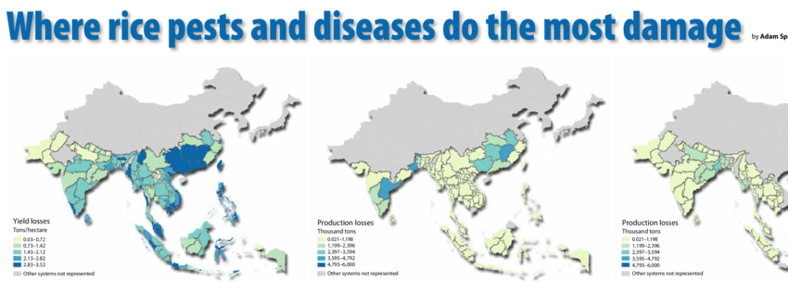

Figure : Where rice pests and diseases do the most damage

As it is shown in the above diagram [6] in the country of Sri Lanka, the yield losses due to discases and pests are mostly in the red zone. Because of this annually 35% of yield goes to waste.

Figure :Production lost

By looking at the figure 2 [10] it is apparent that 34% of all harvest in Asia are lost due to insects as well as 9.1% of it being lost due to diseases. All of these considered only 45% of harvest is produced.

If these diseases or pests are not treated properly they can spread quickly to other crops making them unhealthy as well. Since there are many types of diseases and pests is virtually impossible for common farmer to have the knowledge about proper pesticide and treatments.

As a solution for all these issues a mobile application will be proposed.

## **1.2 Literature Survey**

### **1.2.1 Agrio Mobile Application**

This is a widely used plant disease identification application worldwide. He determined number of diseases related to fruits, vegetables, etc. Agrio is an artificial intelligence-based solution that helps you to identify and treat plant diseases and pests in your fields, farms, and gardens. We offer comprehensive Integrated Pest Management (IPM) protocols to optimize results and reduce treatment costs. It also gives you forecasts and sends you alerts when problems arise in your area. This application allows you to protect vegetables, fruits, flowers, trees, and other plants from damage. When you are uncertain about the results of artificial intelligence algorithms, share your images with a group of agronomists and extensionists you may have. If you have a conclusion, an automatic response will be sent to you in a few seconds. If you choose to present to a team of experts, they will share their opinion based on the photos they upload and give you suggestions to solve the problem. [1]

### **1.2.2 Crop Farmers Mobile Application**

Help the farmer with summary information about crops, fruits, and vegetables. Climatic and Soil Requirements, Avocado, Banana, Beans, Carrot, Jackfruit, Cucumber, Garlic, Irish Potato, Lettuce, Sorghum, Watermelon, Onion, Bell Peppers and Peppers, Pineapple and Eggplant sour Info explains how. The app also describes the most common causes of pests and diseases, symptoms, how they spread, and prevention and control measures. Where possible, app will advise on suitable farming methods to control crop pests. This app can be used as a guide for new farmers, or anyone involved in farming around the world. Learn new farming techniques/methods to avoid attacking your crops. It also provides information on best practices for to follow to improve farmers' performance in growing these crops. [2]

### **1.2.3 Detection of leaf diseases and Wheat Using Image Processing**

This study, mainly carried out by Rittika Raichaudhuri and Rashmi Sharma, aims to use image processing as the primary technology to detect foliar diseases in the field of wheat production. The former algorithm is used to extract important information from the leaf and the second algorithm is used to detect the disease it is infected with. For image processing and segmentation, the use of k-means algorithm and convenience filter has been proposed. Pattern recognition is performed by PCA or GLCM and classification by SVM or ANN. [3]

### **1.2.4 Pest Identification using Image Processing using Neural Network**

This study is done by Johnny L. Miranda, B. Gerardo, Bartolome T. Tanguilig, Sajad Sabzi with the goal of classifying pests in crops. Pest infestation in rice production is a challenging task for crop technicians and farmers. Pest infestation can cause serious losses and also affect the income of farmers. Decisions for pest predictions can be made by estimating the density of farmers. Existing detection techniques for these species involve the use of various traps to detect their presence. In this study, an identification system was developed for automatic detection of field insect pests. Continuous monitoring by a wireless camera for video recording is done by catching the insect with a sticky trap. Various imaging techniques are used to identify and extract the captured insect. Neural network was used to identify the extracted insect pests. The new automated detection system developed in this study provides reliable detection. [4]

### **1.2.5 Pest & Crops Mobile application**

This application also widely used for identifying pests and manage crops. Mainly target to identify wheat pest. Also have use image processing algorithms to identify the pests. Also, this application provide pest forecasting information to user. As well as this application has three main category for pests identifications. There are Bees of north America, Insect in Canola and Insects in Wheat [5]

## **Research Gap**

|  |  |  |  |  |  |  |
| --- | --- | --- | --- | --- | --- | --- |
|  | Agrio | Crop Farmers | Diseases and Wheat | Pest Identification | Pest & Crop | E-Ketha |
| Diagnosis of paddy cultivation. | No | Yes | No | No | No | Yes |
| Identify disease that harmful for the cultivation. | Yes | No | Yes | No | No | Yes |
| Give brief description about current situation of the disease. | No | No | Yes | No | No | Yes |
| Give Details about treatment of the disease. | Yes | Yes | No | No | No | Yes |
| Identify pests that harmful for the cultivation. | No | No | No | Yes | Yes | Yes |
| Give Details about treatment of the Pests. | No | No | No | No | Yes | Yes |

Table 1:Comparing existing application and our application features

## **Research Problem**

Rice productivity is something on which the Economy highly depends in Sri Lanka and South Asia. nowadays rice growers are moving away from rice cultivations. The main reason for this is that they cannot afford a reasonable income. This is one of the major problems in the rice cultivation field. The first major problem with paddy is the prevalence of rice diseases. With the discovery of new diseases and ailments day by day, it is difficult for the average farmer to diagnose and treat them. Pests and other unwanted insects that are closely related to diseases also attract crops. These pests can cause disease from the plant in the first place as well as spread the disease. Pests, while not spreading diseases, can contaminate crops for human consumption [7][8][9].

## **OBJECTIVES**

### **2.1 Main Objectives**

Introduction of a mobile application to identify diseases and pests in paddy cultivation. The main objective of identifying potential diseases and pests in paddy plants is to create an Android based mobile application that can analyze leaf changes using the image processing method and detect possible diseases in paddy cultivation. This Android based mobile application is used to detect leaf diseases with the help of automated algorithms and those pests can detect automated algorithms. This uses the database to identify the most vulnerable sheets and present the most accurate result. In addition, the application provides treatment for diseases and pests.

### **2.2 Specific Objectives**

1. Application Identifies possible diseases by analyzing changes on the rice plant leaf. Rice farmers take an image of the rice leaf and upload it through the app using image processing technology. The application compares the color changes of the rice leaf with the data uploaded to the database and identifies whether the leaf could be a disease leaf or not.

2. Application Classifies rice plants according to their disease stage. Once the disease is successfully diagnosed, the leaflet is classified according to its effect. There are normal, risk and so on stages.

3. The application will suggest treatments according to the type of disease and the current status of the disease.

4. App will identify the possible pests by analyzing the rice plant. Rice farmers can capture a video/image of the pests and upload it through the app using video processing technique. The application classifies pests using uploaded data to database.

5. Once the pests have been successfully determined, the pests are classified according to the database data

6. The application will provide treatment suggestions for identified pests.

# **METHODOLOGY**

This section includes detailed descriptions about the techniques and mechanism employed to correctly plant rice plants. The descriptions include how software implementation of the project is carried out, what are the materials and data needed, and how they will be collected.

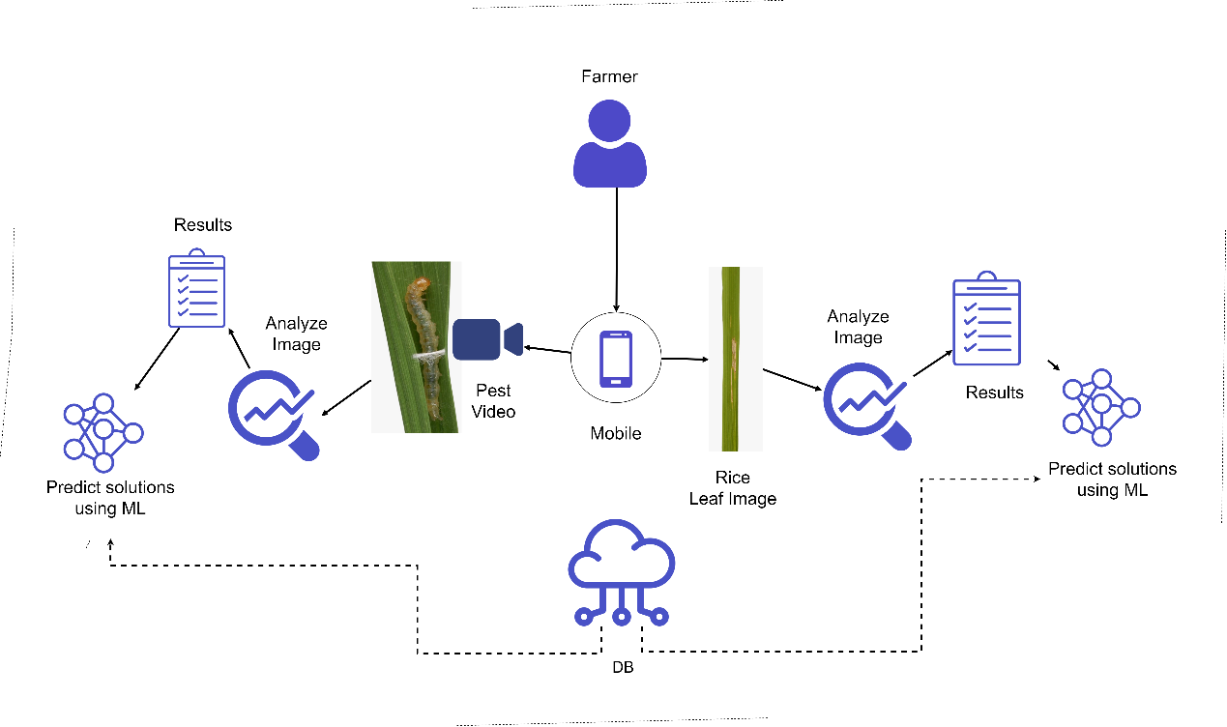

Figure 3:Pest and disease detection overview

Many diseases and pests that affected to the rice plants. Some are black blight, leaf spot, leaf scab, gray spot etc. Many farmers have lack of knowledge to identify the diseases and pests. So, using data mining techniques and analyzing models prepare a database about the harmful diseases and pests to the cultivation. The training database is retrieved with the information provided by the user. When user upload the image of the leaf to the mobile application, system will detect whether it is healthy or diseased. In the case of pests the user can upload a video of the pest for it to be identified. If it is identified as a diseases leaf mobile application will show the treatments that is wanting to heal that disease or if it is pests removal methods such as pesticides will be suggested.

For this process identification of the disease must be done in an accurate way. Image processing techniques such as Grayscale, threshold, median filters, binary images are used for this process to give accurate outcome. Segmentation is the separation or division of an image into different parts. There are various methods of image resolution, ranging from simple apertures to high-color image segmentation methods. Computers cannot detect objects intelligently, and various techniques for image segmentation have been developed. The process of segmentation is based on different elements in the image. This can be color information, border, or part of an image. To implement this application, must use generic algorithms for color image segments.

## **3.2 Research Area**

When it comes to research area, four features were identified. Such as Image processing activities, Classification activity, Detection activities and finally solution prediction. In order to conduct the research, deep learning technology has been taken as the core foundation.

## **3.3 Requirement Gathering and Analyzing**

Due to the importance of requirement gathering and analysis, major emphasis was put to this section. Since there is a need for this process to be strictly on the “disease and pests identification and solution finding” part below mentioned approaches were used.

* Reading research papers relevant to the research problem.
* Studying existing systems related to our research area.
* Contacted experts in Rice Research and Development Institute(RRDI) , Bathalagoda.
* Met with Sri Lankan paddy farmers.

To get an idea about the research problem, studying related research papers are a must. Next step was to understand what types of systems that already exists, so as to see what are lacking and needs improvements. Finally to see if the proposed solution is viable in the current environment, specialists on the field and traditional farmers were contacted.

### **3.4.1 functional requirements**

* Ability to upload disease imagery.
* Identify disease type.
* Ability to upload pest’s video.
* Identify pest type.
* Propose solutions.
* Show proposed solutions.

### **3.4.2 Non-functional requirements**

* Reliability
* Accuracy
* Availability
* Performance
* User friendly

## **3.5 Design**

Design phase encompasses what is needed for the estimation of hardware and system requirements by the creation of a system architecture, due to the needs and specifications being included. The architecture will entail the components separated into manageable levels according to the respective research project member. In this case it will be the “identification pests and diseases then proposing solutions” component.

## **3.6 Tools and Technologies**

### **3.6.1 Tools**

* Android studio
* PyCharm
* OpenCV
* Jupiter notebook
* DB

### **3.6.2 Technologies**

* Machine learning/Deep learning
  + CNN
* Image processing
* Android – java
* Python

## **3.7 Implementation**

In this stage of the project, the implantation of the system will be started. This will be in accordance with the system architecture proposed in the previous design phase. “Identification pests and diseases and proposing solutions” component will be further split into three subcomponents, with them being

* Identification of diseases using imagery
* Identification of pests using videos
* Proposing solutions.

## **3.8 Testing and Maintenance**

As the final phase of the Software development life cycle(SDLC) is the testing and maintenance phase which will be done under the discipline of functional and nonfunctional testing. The functional testing will mainly consider the functional requirements of the system and unit testing will be taken as the basis. Then in order to check the nonfunctional requirements such as performance and availability various nonfunctional testing will be conducted. As for the maintenance of the application after the publication various support features will be added.

## **3.9 WBS**

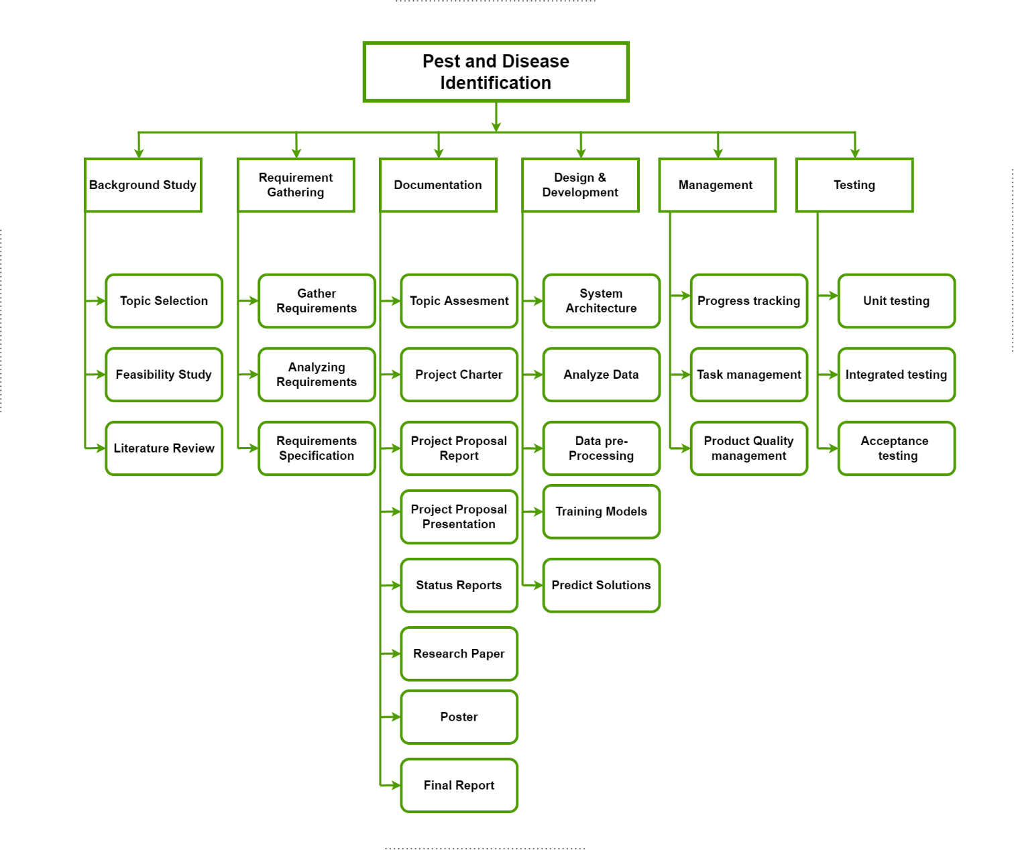

Figure 4:WBS chart

## **3.10 Grant Chart**



Figure 5:grant chart

# **DESCRIPTION OF PERSONAL AND FACILITIES**

|  |  |  |
| --- | --- | --- |
| **Student Details** | **Role** | **Tasks** |
| IT19101620 | Group Member | Finding relevant diseases and pests image datasets for the “Diseases and Pests identification” component.  Finding the most suitable algorithms for the component in order to do image segmentation and classification.  Segmentation of diseases and pests in the uploaded imagery.  Identification of diseases and pests in the uploaded or captured image.  Suggesting appropriate solutions in order to remove or treat the harmed crop by a pest or a disease. |

Table 2:DESCRIPTION OF PERSONAL AND FACILITIES

# **5.BUDGET**

Table 3:budget

# **REFERENCE LIST**

|  |  |
| --- | --- |
| [1] | A. H. Sparks and A. Nelson, "Where rice pests and diseases do the most damage," Researchgate, 12 2012. [Online]. Available: https://www.researchgate.net/publication/270584803_Where_rice_pests_and_diseases_do_the_most_damage. |
| [2] | Google Books, "Crop Loss Assessment in Rice: Papers given at the International Workshop on Crop Loss Assessment to Improve Pest Management in Rice and Rice-Based Cropping Systems in South and Southeast Asia, 11-17 October 1987," *Google Books,* 1987. |
| [3] | Saillog Ltd, "Saillog Ltd," [Online]. Available: https://play.google.com/store/apps/details?id=com.agrio&hl=en_US. [Accessed 20 02 2020]. |
| [4] | Bivatec Pvt, "Crop Farmers App - Apps on Google Play," Bivatec Pvt, [Online]. Available: https://play.google.com/store/apps/details?id=com.bivatec.cropfarmersguide&hl=en_US. [Accessed 20 02 2020]. |
| [5] | R. Raichaudhuri and R. Sharma, "Imaging-Based-Method-for-Precursors-of-Impending-Disease-from-Blood-Traces," *researchgate.* |
| [6] | J. L, M. and B. Gerardo, "Pest Identification using Image Processing Techniques in Detecting Image Pattern through Neural Network," *Semantic Scholar.* |
| [7] | UofM Mobile, "Pest & Crop Management," UofM Mobile, [Online]. Available: https://play.google.com/store/apps/details?id=ca.umanitoba.ipm&hl=en&gl=US. |
| [8] | R. A. and A. , "Identification and recognition of rice diseases and pests using convolutional neural networks," sciencedirect, [Online]. Available: https://www.sciencedirect.com/science/article/abs/pii/S1537511020300830. |
| [9] | M. Eliz and M. L. Pai, "Detection of Rice Leaf Diseases Using Image Processing," Ieeexplore, 2020. [Online]. Available: https://ieeexplore.ieee.org/abstract/document/9076527. [Accessed 02 12 2021]. |
| [10] | S. B. and R. , "Image Processing Techniques for Diagnosing Rice Plant Disease: A Survey," ieeexplore, 03 2020. [Online]. Available: https://ieeexplore.ieee.org/abstract/document/9076527. [Accessed 2 12 2021]. |